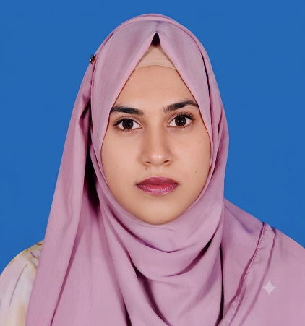
Curriculum Vitae Of
Shirajum Monira Tahera
Address: Board Bazar, National University, Gazipur-1704
Contact:+8801632897748
E-mail: shirajummuniratahira@gmail.com

Career Object

A highly motivated and goal-driven individual with excellent communication, problem-solving, and organizational abilities. Eager to begin a professional career where I can apply my academic knowledge, grow through continuous learning, and make a meaningful contribution to a forward-thinking organization.

Computer Skills
- MS Office Suite (Word, Excel (Basic), PowerPoint)
- Graphics Software (Canva, Photoshop(basic).)
Linguistic Skills

Fluent in Bengali and Basic English interpersonal communication. Also, able to pick new concept quickly and self-motivated to learn. Also, capable to understand Hindi & Urdu language.
Educational Background
- Bachelor Of Social Science (B.S.S.)
Dhaka City College under National UNIVERSITY, Dhanmondi-2
Major: Economies
CGPA: Current SGPA 2.88 (Out of 4)
Pass Year: 2023
- Higher School Certification (HSC)
The Scholars College, Tongi.
Group: Humanities
CGPA: 3.33 (out of 5)
Pass Year: 2019
- Secondary School Certification (SSC)
Birshrestha Munshi Abdur Rouf Public, Peelkhana, Dhaka - 1205
Group: Humanities
CGPA: 3.56 (out of 5)
Pass Year: 2017
Personal Details
- Height: 5.3 inch
- Weight:64 ±
- Eyesight: 6/6, No color blind
- Medical Fitness: Absolutely fit and ready to tackle any work without any physical limitations.
- I have No Affidavit
- I don't wear any Spectacle at all.

Certification

I, the undersigned, hereby declare that I will be responsible for any wrong information provided here.



Shirajum Monira Tahera

