SEO Competitor Analysis
https://isseng.co.uk/ Date: 03-20-2025

Domain Overview

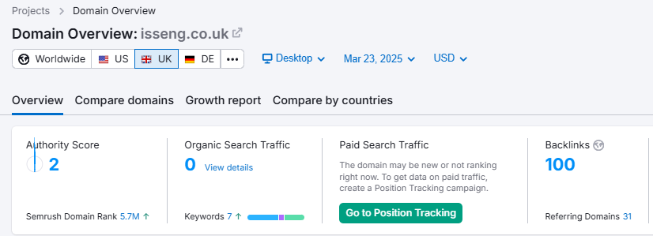
(SEMrush Domain overview of ISSEng.co.uk)

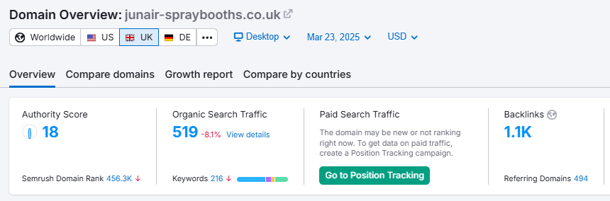
(SEMrush Domain overview of Junair-spraybooths.co.uk)

Junair's website already has a strong Authority Score advantage. Since a website's performance is largely measured by its Authority Score—the higher, the better—this gives Junair a competitive edge. As a result, the site currently gains 519 organic search visits per month and has 1,100 backlinks pointing to it.

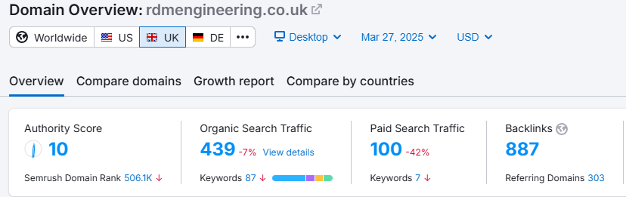
(SEMrush Domain overview of rdmenginerring.co.uk)

What I observed with RDM Engineering, aside from the data being greater than your website, is that they have paid search traffic. This indicates that they are actively running a Google Ads campaign. Please see the image below for reference.

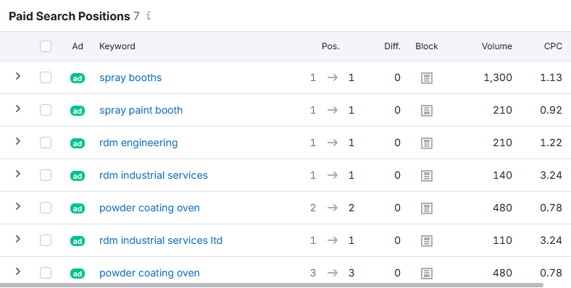
(SEMrush Paid Ads Keywords of rdmenginerring.co.uk)

They are ranking #1 for the majority of their paid ads keywords, with an average monthly spend of $128, resulting in an additional 100 paid ads traffic.

Anchor Text Used & Keywords Intent
Most of their anchor texts consist of their brand name. This provides valuable insights into their link-building strategy, making it easier for us to replicate and implement a similar campaign.
I noticed that more than half of their keywords have informational intent, which indicates that they invest in high-quality content and can rank organically. This is a positive signal, showing that their pages provide value and demonstrate expertise in their field.

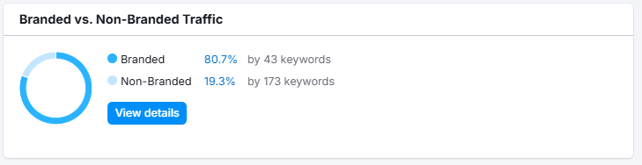(Anchor Text of Junair-spraybooths.co.uk) | 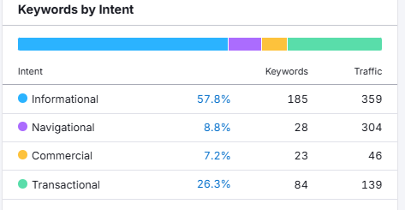  (Keywords Intent of Junair-spraybooths.co.uk)

Opportunity Keywords
Below are the keywords that both of your competitors are already ranking for (see columns 4 and 5). This presents a great opportunity to identify which keywords we should focus on.
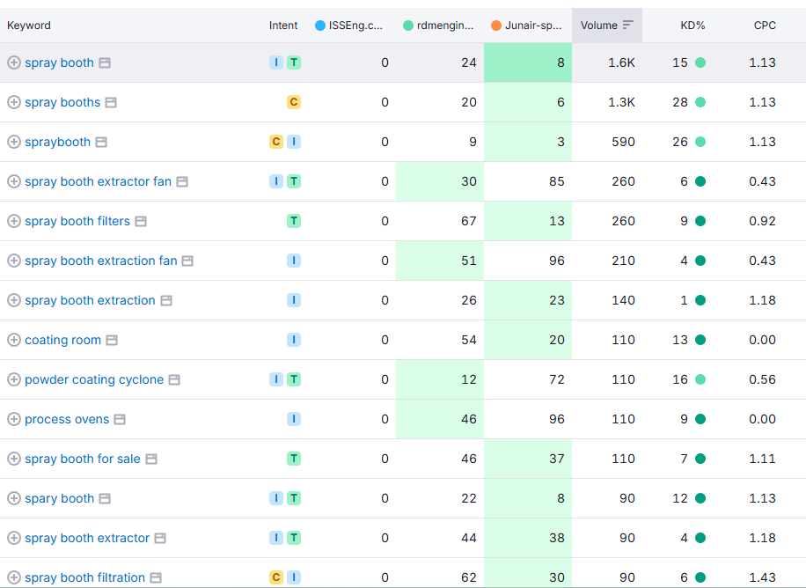
(SEMrush Keyword Gap Report)

